Title: Exploratory Data Analysis of Superstore Retail Sales

Name: Silindile

Surname: Dhlamini

Task 1: Datheon Internship

Date: 22/10/2026

Tools: Python, Pandas, NumPy, Matplotlib, Seaborn and Jupyter Notebook

Dataset: Superstore Retail Sales (2015–2018)

Contents
1.Introduction: 2
1.1 Aim 2
1.2 Objectives 2
Dataset Description and Data Preprocessing: 2
2.1 Dataset Description 2
2.2 Data Quality Assessment 2
2.3 Data Cleaning 3
2.4 Data Transformation and Feature Engineering 3
2.5 Final Dataset 3
Exploratory Data Analysis and Descriptive Statistics: 4
3.1 Overall Business Performance 4
3.2 Descriptive Statistics 4
3.3 Distribution and Outlier Analysis 4
3.4 Transaction Profitability 5
Customer Purchasing Behaviour Analysis 5
4.1 Customer Spending Patterns 5
4.2 Highest-Spending Customers 6
4.3 Relationship Between Customer Spending and Profitability 7
4.4 Business Implications 7
Monthly Sales Trends and Seasonality Analysis 8
5.1 Monthly Sales Performance 8
5.2 Seasonal Sales Patterns 9
5.3 Interpretation of Seasonal Trends 10
5.4 Business Implications 10
Product Category Revenue and Profitability Analysis 10
6.2 Category Profitability 11
6.3 Revenue Versus Profitability 11
6.4 Business Implications 11
Regional and Customer Segment Performance Analysis 12
7.1 Regional Sales Performance 12
7.2 Regional Profitability Differences 12
7.3 Customer Segment Performance 13
7.4 Business Implications 13
Discount Sensitivity and Profitability Analysis 14
8.1 Relationship Between Discounts and Profitability 14
8.2 Profitability Across Discount Levels 14
8.3 Interpretation of Discount Sensitivity 15
8.4 Business Implications 16
Key Findings and Business Recommendations 16
9.1 Summary of Key Findings 16
9.2 Business Recommendations 17
9.3 Overall Business Implications 17
Limitations and Conclusion 18
10.1 Limitations of the Analysis 18
10.2 Conclusion 18

Figure 1:Overall business performance indicators 6
Figure 2:Outliers Analysis 7
Figure 3:Sales and profit outliers 7
Figure 4:Top five customers by total sales revenue 8
Figure 5: Top 10 Customers by Total Sales Revenue 8
Figure 6:Relationship between customer sales and profit 9
Figure 7:Relationship between customer sales and profit 9
Figure 8:Monthly Sales and Profit Trends 10
Figure 9: Monthly Orders and Average Order Value 10
Figure 10:Average Monthly Sales (2015–2018) 11
Figure 11:Monthly Sales Seasonality by Year 11
Figure 12: Product category sales and profitability performance 12
Figure 13:Regional sales and profitability performance 14
Figure 14:Total sales and profit by region 15
Figure 15:Customer segment sales and profitability performance 15
Figure 16:Sales and profitability by discount level 16
Figure 17:Relationship between discount and profit 17
Figure 18:Profit margin by discount level 17

1.Introduction:
Retail businesses generate substantial volumes of transactional data that can be analysed to understand customer purchasing behaviour, sales trends, product performance and profitability. Exploratory Data Analysis (EDA) provides an approach for identifying patterns, detecting anomalies and generating insights that support business decision-making.
This project investigates the Superstore Retail Sales dataset using Python-based data cleaning, statistical analysis and visualization techniques. The dataset contains information about customer orders, product categories, geographical regions, sales revenue, discounts and profit.
The analysis focuses on understanding sales performance, identifying profitable and unprofitable business segments, examining seasonal purchasing patterns and evaluating the relationship between discounts and profitability.

1.1 Aim
To conduct exploratory data analysis of Superstore retail transactions to identify sales patterns, customer purchasing behaviour and factors associated with business profitability.

1.2 Objectives
- Clean and preprocess the retail sales dataset by identifying missing values, duplicates and inconsistent records.
- Analyse sales distributions, customer purchasing behaviour and monthly sales seasonality.
- Evaluate revenue and profitability across product categories, geographical regions and customer segments.
- Investigate the relationship between discount rates and profitability.
- Develop data-driven recommendations to support retail business decision-making.

Dataset Description and Data Preprocessing:

2.1 Dataset Description
The Superstore Retail Sales dataset was used to investigate retail business performance between January 2015 and December 2018. The original dataset contained 10800 records and 21 columns representing customer orders, product information, geographical locations, sales revenue, quantities, discounts and profits.
The dataset includes both categorical and numerical variables. Categorical variables include Region, Category, Sub-Category, Segment and Ship Mode, while numerical variables include Sales, Quantity, Discount and Profit.
The Order Date and Ship Date variables provide temporal information for analysing sales trends, seasonality and shipping duration.

2.2 Data Quality Assessment
An initial assessment was conducted using Python and Pandas to examine the dataset's structure, missing values, duplicated records and data types.
The assessment identified 806 records containing missing sales information. Further inspection revealed that these records belonged to additional tables, including People and Returns, which had been appended to the main sales dataset.
The original dataset also contained 504 exact duplicate rows. However, these were associated with the appended records rather than duplicated sales transactions.
Additionally, 817 missing values were identified in the Postal Code column before cleaning.

2.3 Data Cleaning
Data cleaning was performed to improve data quality and ensure that subsequent analyses were based on valid retail transactions.
Records with missing Sales values were excluded because they did not represent valid sales transactions. This reduced the dataset from 10800 to 9,994 records.
After removing the unrelated records, no exact duplicate transactions remained, and all 9994 Row ID values were unique.
Eleven missing Postal Code values remained in the cleaned dataset. These records were retained because postal codes were not required for the primary analytical objectives, and the remaining transaction information was complete.

2.4 Data Transformation and Feature Engineering
The Order Date and Ship Date columns were converted into datetime format to support temporal analysis.
Additional variables were created, including:
- Year: Extracted from the order date to support annual comparisons.
- Month: Extracted from the order date to investigate monthly sales patterns.
- Year-Month: Created to aggregate sales and profit by calendar month.
- Shipping Days: Calculated as the difference between shipping and order dates.
Both date columns were converted successfully without producing invalid date values.
The cleaned dataset covered transactions from 3 January 2015 to 30 December 2018.

2.5 Final Dataset
Following data cleaning and feature engineering, the final dataset contained 9994 records and 25 columns.
The cleaned dataset was exported as superstore_sales_cleaned.csv for reproducibility and further analysis.
The preprocessing process ensured that subsequent statistical analyses and visualizations were based on consistent and relevant retail transaction records.

Exploratory Data Analysis and Descriptive Statistics:

3.1 Overall Business Performance
Exploratory Data Analysis (EDA) was conducted using Python and Pandas to examine the statistical characteristics of the cleaned Superstore Retail Sales dataset. The analysis focused on sales revenue, profitability, transaction quantities, customer activity and order volumes.
The dataset generated total sales revenue of $2297200.86 and total profit of $286397.02 between 2015 and 2018. A total of 5009 unique orders were placed by 793 customers, representing 3873 units sold.
The overall profit margin was 12.47%, indicating that the business generated approximately $12.47 in profit for every $100 in sales revenue.
Figure 1:Overall business performance indicators
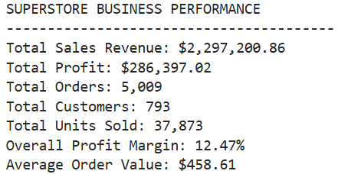

3.2 Descriptive Statistics
Descriptive statistical analysis was performed to examine the distribution of sales and profit across individual transaction records.
The mean sales value was approximately $229.86, while the median was $54.49. The considerable difference between these values indicates that most transaction lines involved relatively small sales amounts, while a smaller number of high-value transactions increased the overall average.
Sales values ranged from $0.44 to $22638.48, demonstrating substantial variation in transaction values.
The profit variable also showed considerable variability, ranging from a maximum loss of $6599.98 to a maximum profit of $8399.98.

3.3 Distribution and Outlier Analysis
The sales distribution exhibited strong positive skewness, with a skewness coefficient of 12.973. This indicates that most transactions generated relatively low sales values, while a small number of transactions generated exceptionally high revenue.
The profit distribution also exhibited positive skewness, with a coefficient of 7.561.
The Interquartile Range (IQR) method was used to identify unusually high sales values. A total of 1,167 observations, representing approximately 11.68% of the cleaned dataset, were identified as sales outliers.
These observations were retained because high-value purchases may represent legitimate business transactions rather than data errors.
Figure 2:Outliers Analysis
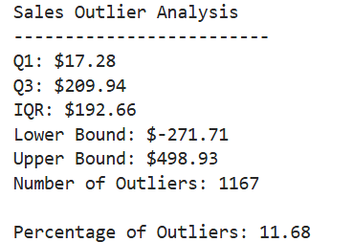
Figure 3:Sales and profit outliers
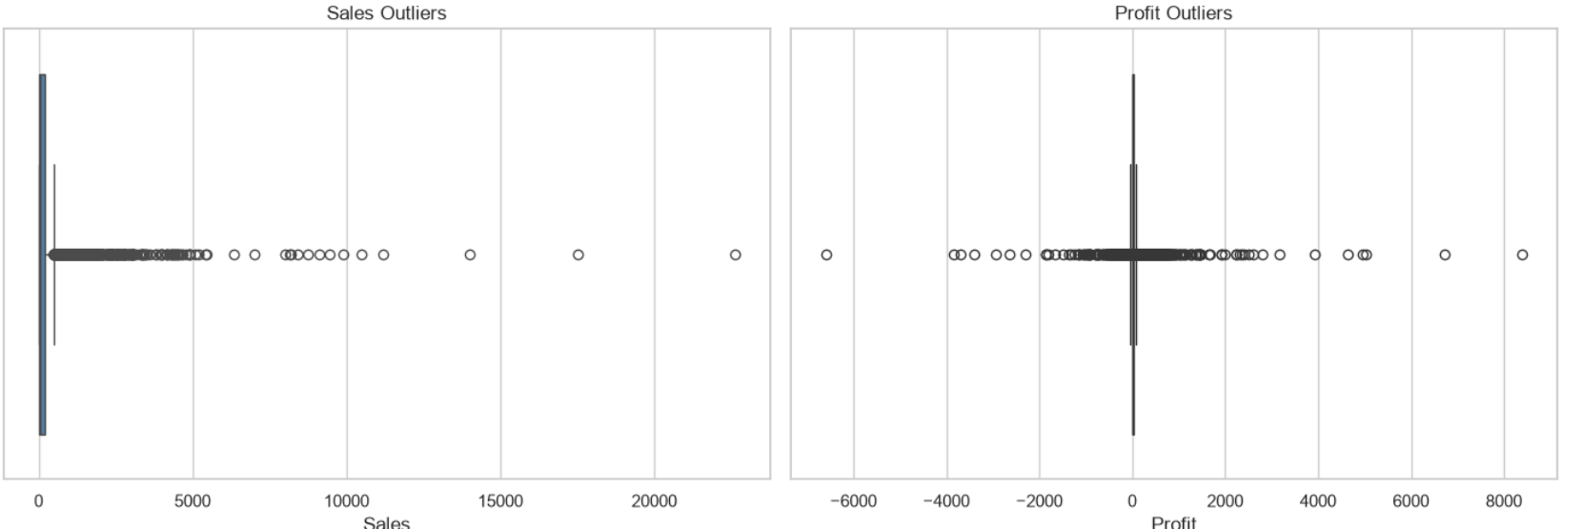

3.4 Transaction Profitability
The analysis revealed that 8058 transaction lines (80.63%) generated positive profits, while 1871 transaction lines (18.72%) generated losses. The remaining 65 transaction lines (0.65%) recorded zero profit.
Although the business was profitable overall, the proportion of loss-making transaction lines suggests that certain products, pricing decisions or discount practices may negatively affect financial performance.
These findings highlight the importance of evaluating profitability alongside sales revenue rather than relying exclusively on total sales as an indicator of business success.

Customer Purchasing Behaviour Analysis

4.1 Customer Spending Patterns
Customer purchasing behaviour was analysed to understand differences in spending, order frequency and profitability. The analysis involved grouping transactions by Customer ID and Customer Name and calculating total sales, total profit, quantities purchased and the number of unique orders placed by each customer.
The dataset contained 793 unique customers, with an average total spending of approximately $2896.85 per customer. The median customer spending was $2256.39, indicating that some high-spending customers increased the overall average.
Customers placed an average of approximately 6.32 orders during the study period, with a median of six orders and a maximum of 17 orders per customer.
These findings indicate variation in customer purchasing behaviour, with some customers contributing considerably more revenue than others.

4.2 Highest-Spending Customers
The analysis identified customers who contributed the most revenue to the business.
Figure 4:Top five customers by total sales revenue
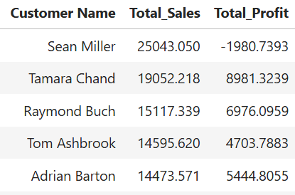
Sean Miller was the highest-spending customer, generating $25043.05 in revenue. However, transactions associated with this customer resulted in an overall loss of $1980.74.
In contrast, Tamara Chand generated $19052.22 in revenue and contributed $8981.32 in profit.
This demonstrates that customers generating high sales revenue do not necessarily contribute positively to business profitability.
Figure 5: Top 10 Customers by Total Sales Revenue
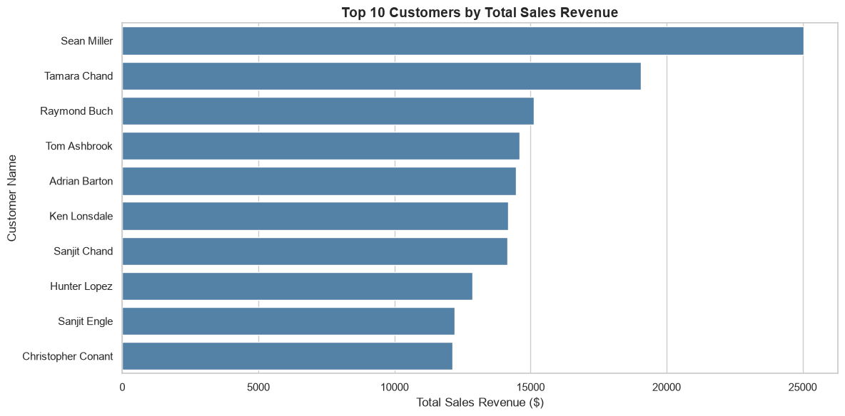

4.3 Relationship Between Customer Spending and Profitability
The Pearson correlation coefficient between total customer sales and total customer profit was approximately 0.506, indicating a moderate positive linear relationship.
This suggests that customers with higher total spending generally tend to contribute higher profits. However, the relationship is not sufficiently strong to conclude that higher customer spending always results in greater profitability.
Further analysis revealed that 155 customers, representing approximately 19.55% of the customer base, generated negative total profits.
These findings indicate that customer profitability varies considerably and may be influenced by product selection, discount rates and purchasing patterns.
Figure 6:Relationship between customer sales and profit
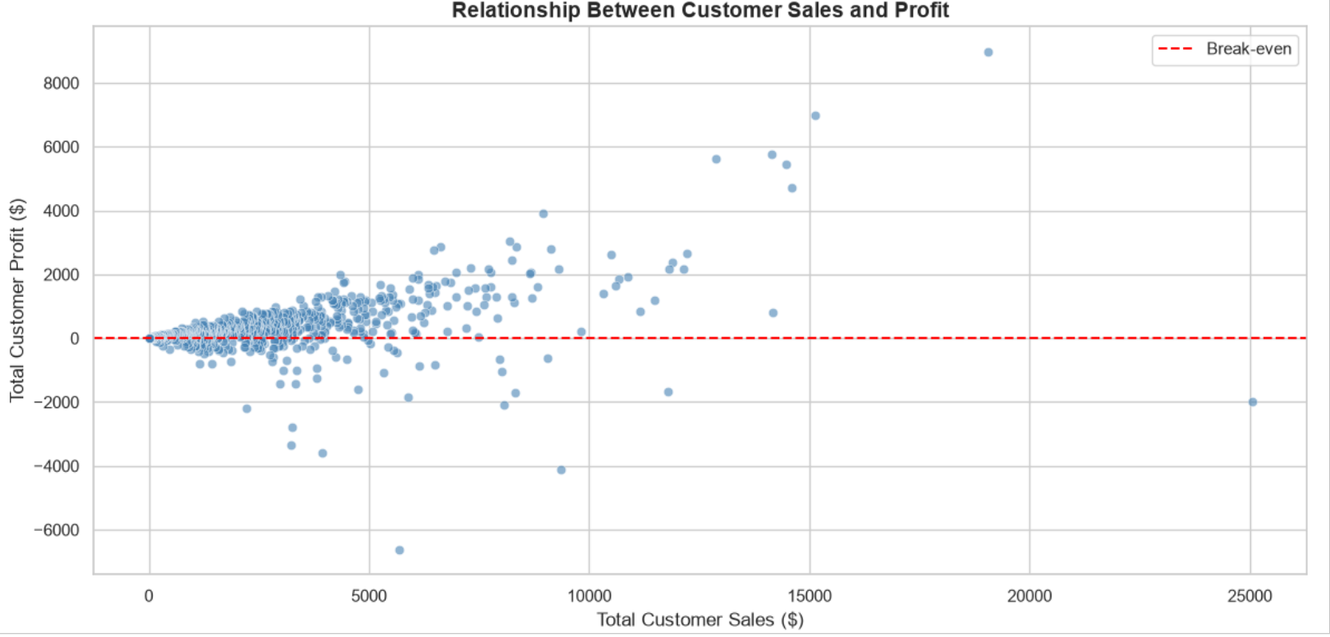
Figure 7:Relationship between customer sales and profit
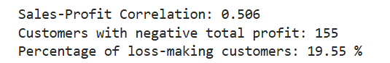

4.4 Business Implications
The findings highlight the importance of evaluating customer relationships using both revenue and profitability indicators.
Although high-spending customers contribute substantially to total sales, some generate losses that may reduce overall business performance.
Management should therefore investigate loss-making customer accounts, evaluate discounting practices and identify opportunities to improve profitability while maintaining valuable customer relationships.
Customer segmentation based on purchasing behaviour and profitability could also support more targeted marketing and pricing strategies.

Monthly Sales Trends and Seasonality Analysis

5.1 Monthly Sales Performance
Figure 8:Monthly Sales and Profit Trends
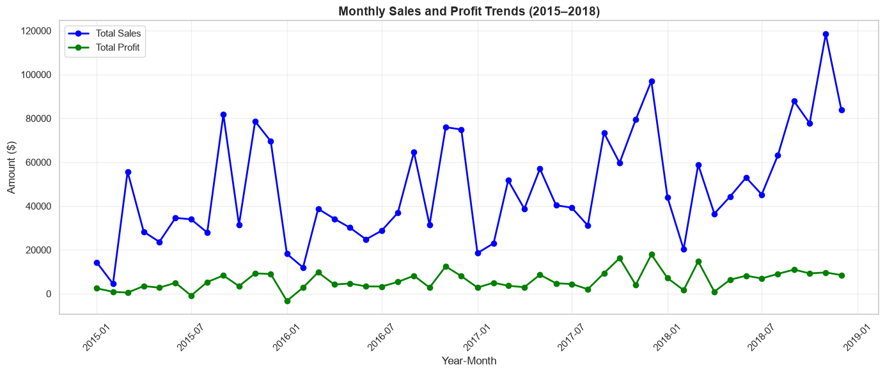
Figure 9: Monthly Orders and Average Order Value
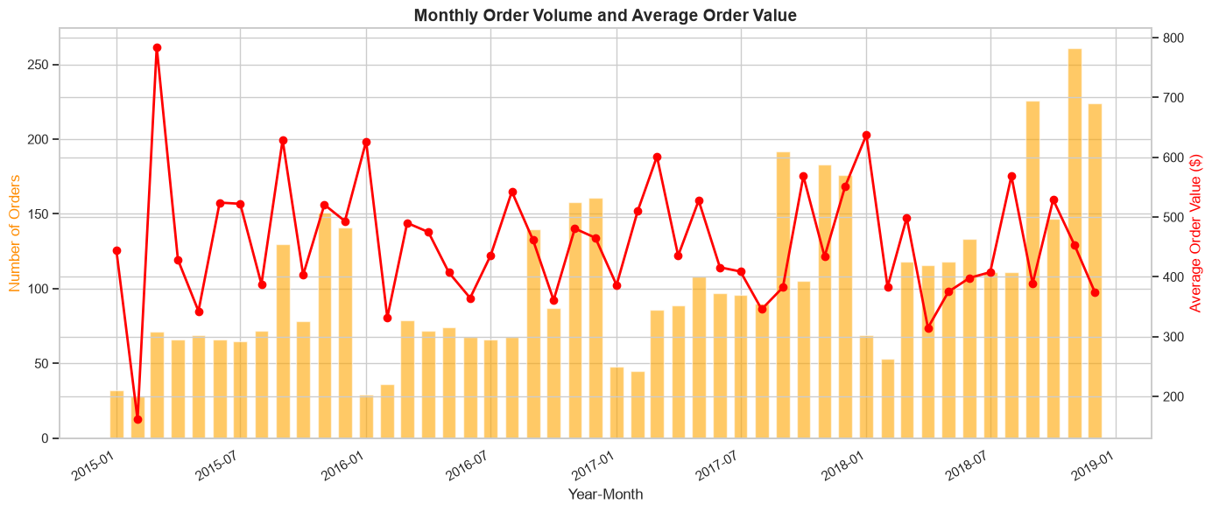
Monthly sales analysis was conducted to investigate temporal variations in retail revenue and identify periods of increased and decreased customer demand. The Order Date variable was used to aggregate sales revenue, profit and unique orders by calendar month between January 2015 and December 2018.
The results revealed considerable variation in monthly sales performance throughout the study period.
The highest monthly revenue was recorded in November 2018, with total sales of $118447.83. In contrast, February 2015 recorded the lowest monthly revenue of $4519.89.
These findings demonstrate substantial differences in monthly revenue generation and suggest that retail sales may be influenced by seasonal purchasing patterns and changes in customer demand.

5.2 Seasonal Sales Patterns
To investigate seasonality, average sales revenue was calculated for each calendar month across the four-year study period.
Figure 10:Average Monthly Sales (2015–2018)
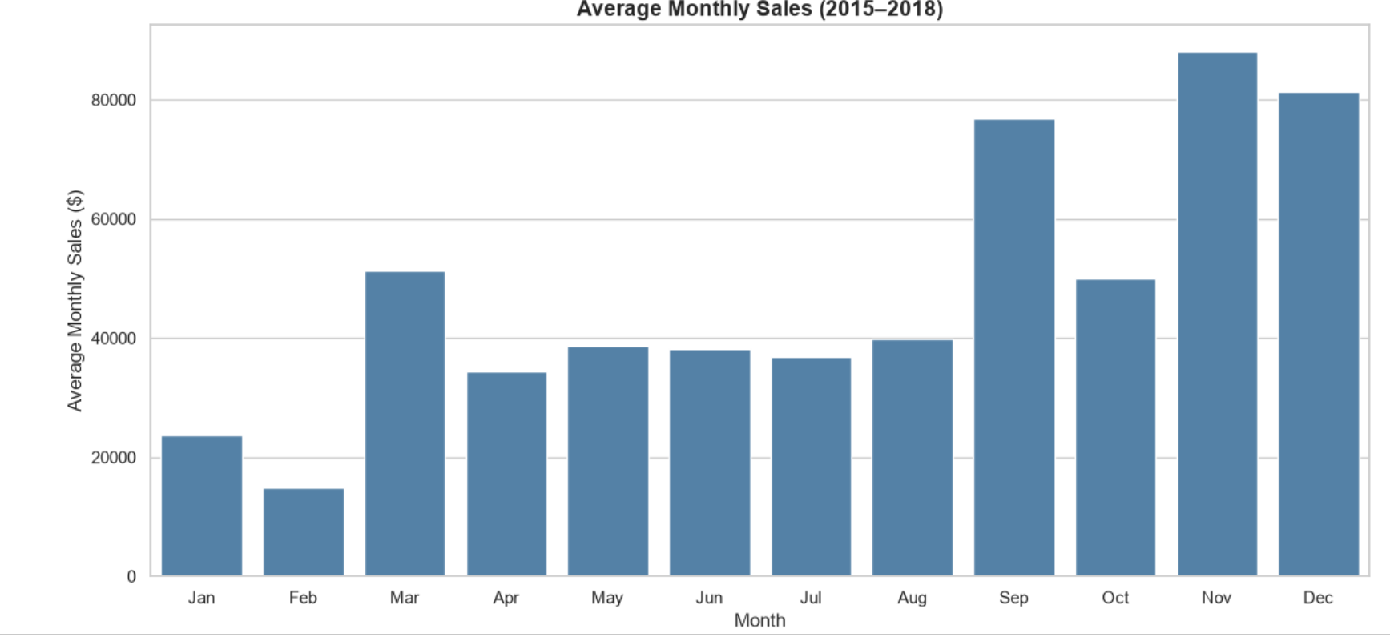
Figure 11:Monthly Sales Seasonality by Year
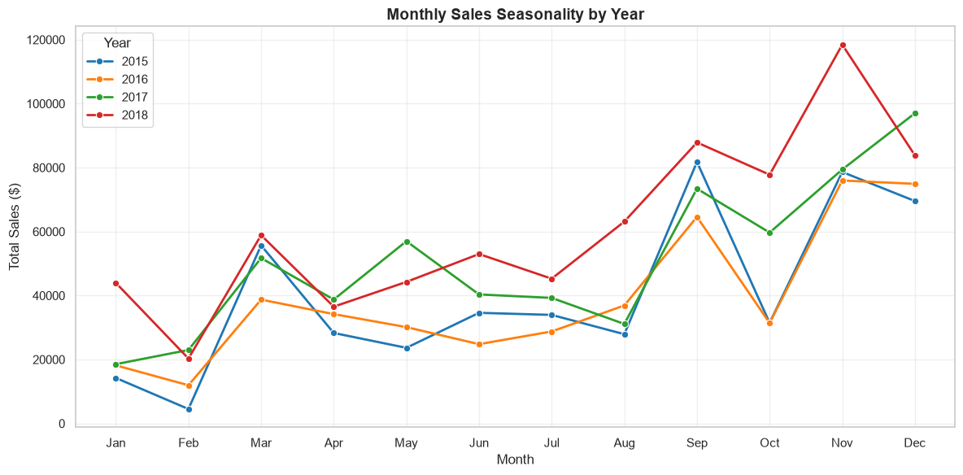
November recorded the highest average monthly sales revenue of $88,115.27, followed by December at $81,323.38 and September at $76,912.49.
February recorded the lowest average monthly sales revenue of $14,937.81, followed by January at $23,731.21.
The average sales revenue recorded in November was approximately 5.9 times higher than that recorded in February, indicating a substantial difference between peak and low-sales periods

5.3 Interpretation of Seasonal Trends
The results indicate that sales revenue was generally stronger toward the final months of the year, particularly September, November and December.
These patterns may be associated with seasonal shopping activities, promotional campaigns, holiday-related purchasing or changes in customer demand. However, the available analysis does not establish the specific causes of these variations.
The relatively low average sales recorded in January and February suggest that these months experienced weaker demand compared with the peak sales periods.
The findings demonstrate the importance of considering seasonal variation when evaluating business performance and developing operational plans.

5.4 Business Implications
Understanding monthly sales patterns can support improved inventory management, staffing decisions, marketing strategies and financial planning.
Management should consider preparing for increased customer demand during September, November and December by ensuring adequate inventory availability and operational capacity.
During lower-sales periods, particularly January and February, the business could investigate targeted promotional activities and customer engagement strategies to stimulate demand.
However, promotional decisions should also consider profitability to avoid increasing revenue through excessive discounting that may generate financial losses.

Product Category Revenue and Profitability Analysis
Product category analysis was conducted to evaluate differences in sales revenue, profitability, quantities sold and order volumes across the three major product categories: Technology, Furniture and Office Supplies.
The analysis was performed by grouping transactions according to product category and calculating total sales, total profit, total quantity sold, unique orders, profit margins and revenue contributions.

Figure 12: Product category sales and profitability performance
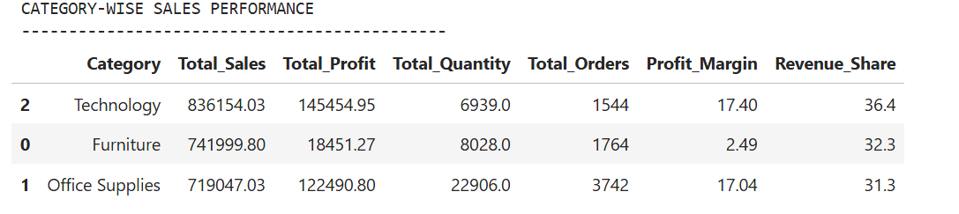
Technology generated the highest sales revenue of $836154.03, accounting for 36.40% of total business revenue. Furniture followed with $741999.80 (32.30%), while Office Supplies generated $719047.03 (31.30%).
Although Office Supplies generated the lowest revenue among the three categories, it recorded the highest quantity sold, with 22906 units.
These findings demonstrate that product categories differ considerably in their revenue contributions and sales volumes.

6.2 Category Profitability
Profitability analysis revealed substantial differences in financial performance across product categories.
Technology generated the highest total profit of $145454.95 and achieved a profit margin of 17.40%, making it the strongest-performing category in terms of both revenue and profitability.
Office Supplies generated $122490.80 in profit, with a profit margin of 17.04%. Despite generating less revenue than Furniture, Office Supplies contributed considerably more profit.
Furniture generated $18451.27 in profit and recorded the lowest profit margin of 2.49%.
The relatively low profitability of Furniture suggests that a substantial proportion of its revenue may be offset by product costs, discounts or losses associated with specific products.
However, further subcategory-level analysis would be required to determine the underlying causes.

6.3 Revenue Versus Profitability
The results highlight the importance of distinguishing between revenue generation and actual profitability.
Furniture contributed 32.30% of total revenue but generated substantially less profit than Technology and Office Supplies.
In comparison, Technology and Office Supplies achieved profit margins above 17%, indicating stronger profit generation relative to their sales revenue.
These differences suggest that high sales revenue does not necessarily translate into strong financial performance.
Consequently, evaluating product categories using profit margins alongside revenue provides a more comprehensive understanding of business performance.

6.4 Business Implications
The findings suggest that management should prioritise profitability improvement within the Furniture category.
Further investigation of Furniture subcategories, product costs, pricing strategies and discount practices could help identify the factors contributing to its low profit margin.
Technology and Office Supplies demonstrate relatively strong profitability and may provide opportunities for sustainable business growth.
Management should therefore consider strategies that maintain demand in profitable categories while addressing potential inefficiencies and losses within Furniture.
Overall, category-level profitability analysis can support better inventory allocation, pricing decisions and product portfolio management.

Regional and Customer Segment Performance Analysis

7.1 Regional Sales Performance
Regional sales analysis was conducted to evaluate geographical differences in revenue generation, profitability and customer purchasing activity. The analysis focused on four geographical regions: West, East, Central and South.
Sales transactions were grouped by region to calculate total revenue, total profit, quantity sold, number of unique orders, profit margins and contributions to overall sales.
Figure 13:Regional sales and profitability performance
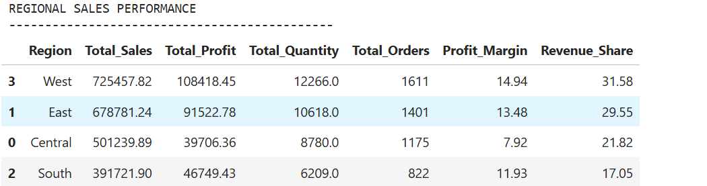

The West region generated the highest sales revenue of $725457.82, accounting for 31.58% of total business revenue. The region also recorded the highest total profit of $108418.45 and achieved a profit margin of 14.94%.
The East region ranked second, generating $678781.24 in sales revenue and $91522.78 in profit, with a profit margin of 13.48%.
Central generated $501239.89 in revenue but recorded the lowest profit margin of 7.92%. Despite generating more revenue than South, Central contributed less total profit.
South generated the lowest revenue of $391721.90 but achieved a higher profit margin of 11.93% compared with Central.

7.2 Regional Profitability Differences
The findings demonstrate that revenue generation and profitability vary considerably across geographical regions.
West and East achieved relatively strong financial performance, contributing the largest shares of total revenue and profit.
In contrast, Central recorded the weakest profitability relative to sales revenue.
The lower profit margin in Central may be associated with differences in product mix, discounting practices, operating costs or customer purchasing behaviour. However, further analysis is required to establish the factors responsible for this pattern.
These findings highlight the importance of considering regional profitability alongside revenue when evaluating business performance.
Figure 14:Total sales and profit by region
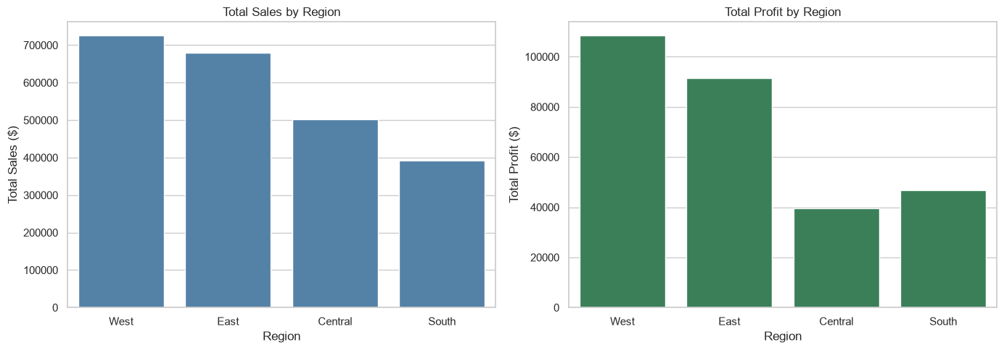

7.3 Customer Segment Performance
Customer segment analysis was conducted to examine differences in sales revenue, profitability and order volumes across three customer segments: Consumer, Corporate and Home Office.
Figure 15:Customer segment sales and profitability performance
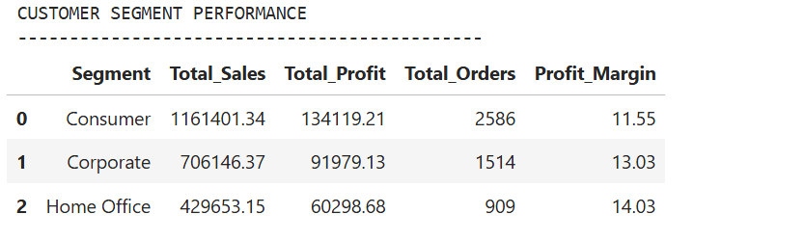
The Consumer segment generated the highest revenue of $1161401.34 and contributed $134119.21 in profit. It also recorded the highest number of orders, with 2586 unique orders.
The Corporate segment generated $706146.37 in revenue and $91979.13 in profit, achieving a profit margin of 13.03%.
Home Office generated the lowest revenue of $429653.15 but recorded the highest profit margin of 14.03%.
These results indicate that the Consumer segment is the largest contributor to overall business revenue, while Home Office demonstrates the strongest profitability relative to sales.

7.4 Business Implications
The regional analysis suggests that management should investigate the factors contributing to Central's relatively low profit margin.
Reviewing product-level profitability, discount practices and customer purchasing patterns within Central could help identify opportunities for improving financial performance.
West and East demonstrate relatively strong performance and may provide useful insights into successful product and pricing strategies.
The customer segment analysis indicates that Consumer customers remain important for revenue generation, while Home Office customers represent a potentially attractive segment for profitable growth.
Management should therefore consider segment-specific marketing and pricing strategies that support revenue growth without compromising profitability.
Overall, the findings demonstrate that regional and customer segment analysis can support more targeted business strategies and improved resource allocation.

Discount Sensitivity and Profitability Analysis

8.1 Relationship Between Discounts and Profitability
Discount sensitivity analysis was conducted to investigate the relationship between discount rates and transaction profitability. The analysis involved calculating the Pearson correlation coefficient between Discount and Profit and aggregating sales, profits and transaction counts by discount level.
The Pearson correlation coefficient was -0.219, indicating a weak negative linear relationship between discount rates and transaction profits. This suggests that higher discounts are generally associated with lower profits, although the relationship is not particularly strong.
However, the grouped analysis revealed substantial differences in profitability across discount levels.

8.2 Profitability Across Discount Levels
Figure 16:Sales and profitability by discount level
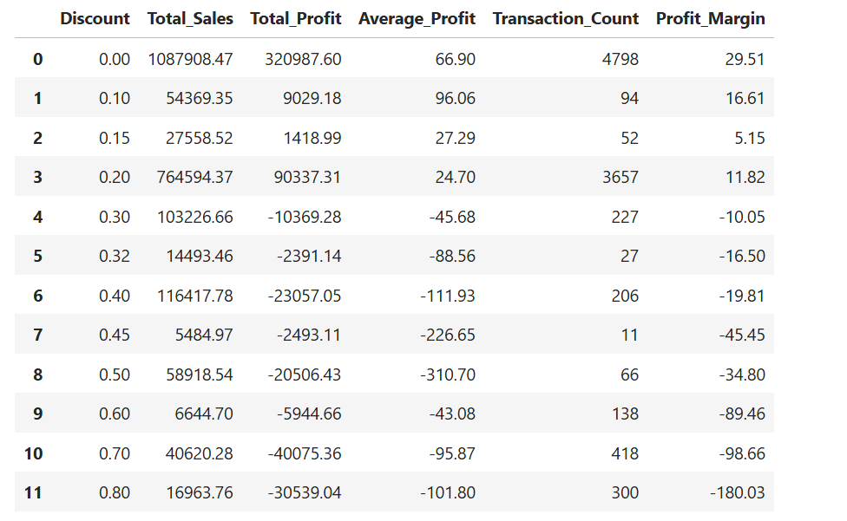

Transactions without discounts generated the highest total profit of $320987.60 and achieved a profit margin of 29.51%.
Transactions receiving discounts between 10% and 20% remained profitable in aggregate, although their profit margins were lower than those of transactions without discounts.
In contrast, every observed discount level of 30% or above generated negative aggregate profits.
At a discount rate of 30%, the profit margin declined to -10.05%, while transactions discounted by 80% recorded a profit margin of -180.03%.
These findings indicate that heavily discounted transactions were associated with substantial financial losses.

8.3 Interpretation of Discount Sensitivity
Figure 17:Relationship between discount and profit
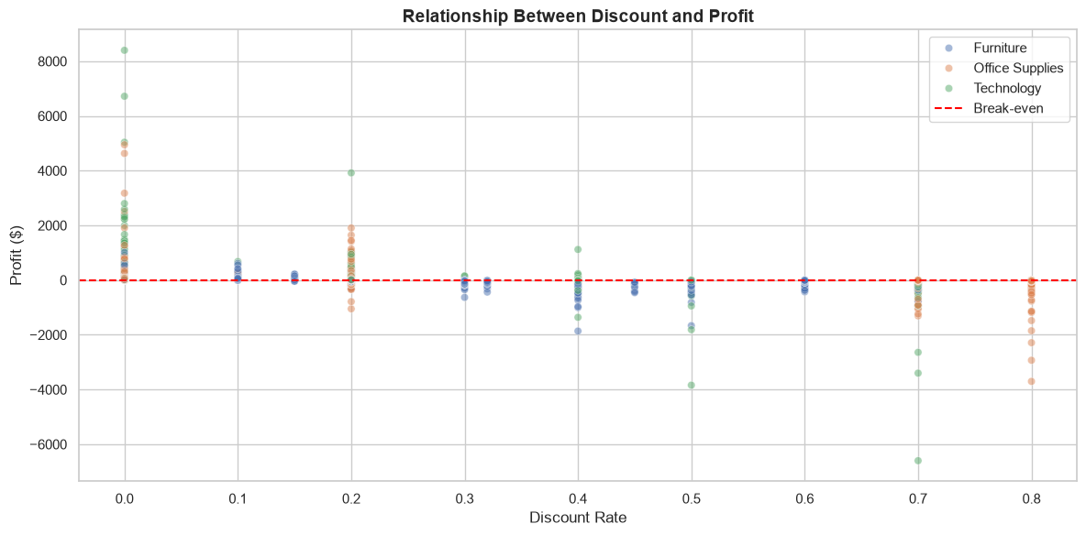
Figure 18:Profit margin by discount level
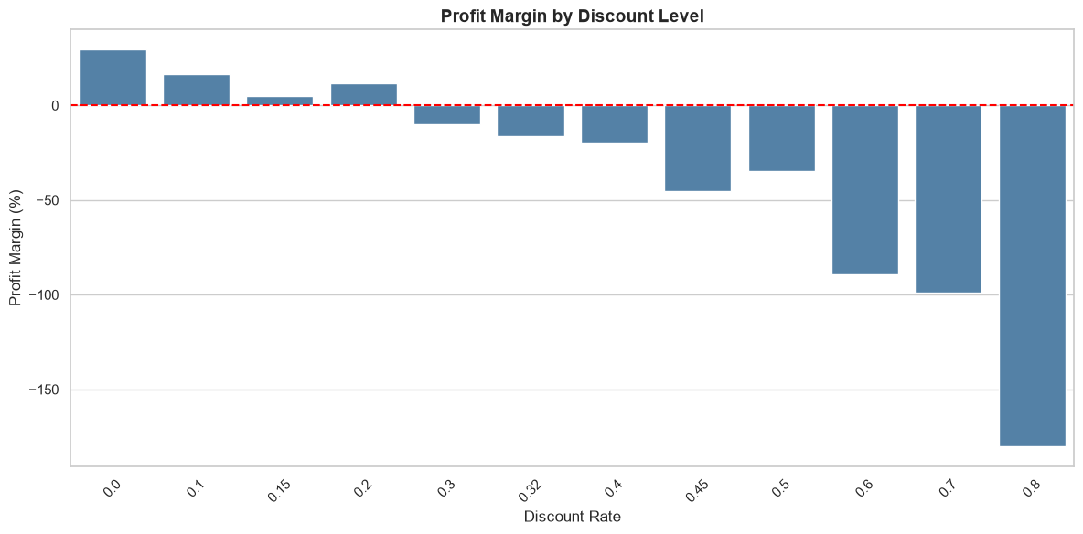
The results suggest that discounting practices may have important implications for business profitability.
Although moderate discounts were associated with positive aggregate profits, higher discount levels consistently corresponded with negative aggregate profitability.
The weak negative correlation coefficient indicates that discount rates alone do not fully explain variations in transaction profits.
Other factors, including product costs, product categories, customer purchasing behaviour and regional pricing differences, may also influence profitability.
Furthermore, the observed relationship does not establish that discounts directly caused the financial losses. Additional analysis controlling for product characteristics and other relevant variables would be necessary to assess the independent effect of discounting.
Nevertheless, the results demonstrate that high-discount transactions represent an important area for financial review.

8.4 Business Implications
Management should review discounting practices, particularly for transactions receiving discounts of 30% or more.
The consistently negative aggregate profit margins observed at these discount levels suggest that existing pricing and promotional strategies may require adjustment.
Introducing discount approval procedures, evaluating product-specific profit margins and monitoring the profitability of promotional campaigns could help reduce financial losses.
Management should also consider examining the relationship between discounts and profitability across product categories and geographical regions to identify where discount-related losses are concentrated.
Overall, the findings highlight the importance of balancing sales growth with profitability when developing retail pricing and promotional strategies.

Key Findings and Business Recommendations

9.1 Summary of Key Findings
The exploratory data analysis identified several important patterns in retail sales performance, customer purchasing behaviour, product profitability, seasonal demand, regional performance and discount sensitivity.
The business generated total sales revenue of $2297200.86 and total profit of $286397.02, achieving an overall profit margin of 12.47%. Although the business was profitable overall, approximately 18.72% of transaction lines generated financial losses.
Customer analysis revealed that high spending did not necessarily translate into high profitability. Approximately 19.55% of customers generated negative total profits, highlighting the importance of assessing customer value using both revenue and profit.
Monthly sales analysis identified strong seasonal variations, with November, December and September recording the highest average monthly sales revenue.
Product category analysis revealed that Technology generated the highest revenue and profit, while Furniture recorded a considerably lower profit margin of 2.49%.
Regional analysis showed that West achieved the highest revenue and profitability, whereas Central recorded the lowest regional profit margin of 7.92%.
Customer segment analysis revealed that Consumer generated the highest total revenue, while Home Office achieved the highest profit margin of 14.03%.
Discount sensitivity analysis identified a weak negative relationship between discount rates and transaction profits (r = -0.219). Furthermore, all observed discount levels of 30% or more were associated with negative aggregate profitability.

9.2 Business Recommendations
Based on the findings, the following recommendations are proposed.
1. Review high-discount pricing strategies
Management should investigate transactions receiving discounts of 30% or more, as these discount levels were consistently associated with negative aggregate profits. Introducing discount approval procedures and monitoring product-level profit margins could help reduce financial losses.
2. Improve profitability within the Furniture category
Furniture generated substantial revenue but achieved a profit margin of only 2.49%. Management should examine Furniture subcategories, pricing structures, product costs and discount practices to identify opportunities for improving profitability.
3. Strengthen customer profitability management
Approximately 19.55% of customers generated negative total profits. Management should evaluate customer profitability alongside sales revenue and investigate loss-making customer accounts to improve pricing and promotional decisions.
4. Prepare for seasonal demand fluctuations
November, December and September recorded the highest average monthly sales revenue. Inventory planning, staffing and promotional activities should account for these peak periods. Management should also investigate strategies to improve sales during lower-demand months, particularly January and February.
5. Address regional profitability differences
Central recorded the lowest regional profit margin at 7.92%, despite generating more revenue than South. Management should investigate regional differences in product mix, discounts and transaction profitability to identify opportunities for improvement.
6. Explore profitable customer segment growth
Home Office achieved the highest profit margin of 14.03%, while Consumer generated the highest revenue. Management should explore opportunities to expand profitable Home Office sales while maintaining strong relationships with Consumer customers.
7. Monitor loss-making transactions
Approximately 18.72% of transaction lines generated negative profits. Regular profitability monitoring could help identify products, customers and pricing decisions that contribute to financial losses.
8. Develop a data-driven performance monitoring framework
Management should establish a consistent approach to monitoring sales revenue, profit margins, customer profitability, product category performance and discount sensitivity. Regular analysis of these indicators could support early identification of financial risks and improve business decision-making.

9.3 Overall Business Implications
The findings demonstrate that revenue growth alone is not sufficient to evaluate retail business performance.
Although Superstore generated substantial sales revenue, differences in profitability across customers, products, regions and discount levels indicate opportunities for improving financial efficiency.
A greater emphasis on profitability monitoring, targeted pricing strategies, customer segmentation and seasonal planning could support more sustainable business performance.
The results also demonstrate the value of exploratory data analysis as a tool for transforming transactional data into actionable business insights.

Limitations and Conclusion

10.1 Limitations of the Analysis
Although the exploratory data analysis provided valuable insights into Superstore's retail performance, several limitations should be acknowledged.
Firstly, the analysis was based on historical transactional data covering January 2015 to December 2018. Consequently, the findings describe business performance during this period and may not accurately represent current market conditions or customer purchasing behaviour.
Secondly, the dataset did not provide detailed information about operational expenses, supplier costs, marketing expenditure or external economic conditions. Therefore, the analysis could not fully explain the factors contributing to differences in profitability across products, customers and geographical regions.
Thirdly, the analysis primarily relied on descriptive statistics, aggregation techniques and correlation analysis. Although these methods were useful for identifying patterns and relationships, they could not establish causal relationships between variables. For example, the negative association between discount rates and profitability does not necessarily indicate that discounts independently caused financial losses.
Fourthly, the analysis was conducted using transaction-level and aggregated customer, category, regional and segment information. More detailed investigations at the product and subcategory levels could provide additional insights into the factors contributing to financial losses.
Finally, the analysis identified seasonal variations using four years of historical data. Although consistent differences in average monthly sales were observed, additional years of data and statistical testing would be required to establish the stability of these seasonal patterns.
Despite these limitations, the analysis provides a useful foundation for understanding retail performance and identifying areas requiring further investigation.

10.2 Conclusion
This project conducted an exploratory data analysis of the Superstore Retail Sales dataset using Python, Pandas, NumPy, Matplotlib and Seaborn. The analysis involved data cleaning, preprocessing, descriptive statistical analysis and the examination of customer purchasing behaviour, monthly sales patterns, product category performance, regional profitability, customer segments and discount sensitivity.
The original dataset contained 10800 records and 21 columns. Following data cleaning and feature engineering, the final dataset contained 9994 valid transaction records and 25 columns.
The analysis revealed that Superstore generated total revenue of $2297200.86 and total profit of $286397.02, achieving an overall profit margin of 12.47%. However, approximately 18.72% of transaction lines generated financial losses, demonstrating that overall profitability did not extend uniformly across all transactions.
Customer analysis showed that high revenue contributions did not necessarily translate into high profitability, with approximately 19.55% of customers generating negative total profits.
Monthly sales analysis identified substantial seasonal variations, particularly during September, November and December, which recorded the highest average monthly sales revenue.
Product category analysis revealed that Technology was the strongest-performing category in terms of revenue and total profit, while Furniture achieved the lowest profit margin of 2.49%.
Regional analysis identified West as the strongest-performing region, while Central recorded the lowest regional profit margin of 7.92%. Customer segment analysis showed that Consumer generated the highest revenue, whereas Home Office achieved the highest profit margin of 14.03%.
Discount sensitivity analysis revealed a weak negative correlation between discount rates and transaction profits (r = -0.219). Additionally, all observed discount levels of 30% or more generated negative aggregate profits, highlighting potential concerns regarding high-discount pricing practices.
Overall, the findings demonstrate that evaluating retail performance requires consideration of both revenue generation and profitability. The analysis identified opportunities for improving discount management, customer profitability, product pricing, regional performance and seasonal planning.
The project successfully demonstrated the application of Python-based exploratory data analysis techniques to transform retail transaction data into meaningful business insights and evidence-based recommendations.
The findings provide a foundation for further analytical investigations and support more informed retail business decision-making.

